MEDICAL RECORDS SYSTEM
@CREATIVITY THINK (9483175986/7019689991)

ABSTRACT:
The Medical Records System is a web-based application designed to centralize and streamline patient medical information for clinics, hospitals, and personal health management. Users can register, log health data, book appointments, view test results, and monitor health history. Administrators manage patient records, assign doctors, review visit logs, track lab tests, and analyze healthcare data through dashboards. Built using Django and Django Rest Framework for backend functionality and React with Recharts for frontend analytics, the system provides secure, scalable, and real-time management of medical records. This platform enhances healthcare efficiency, patient monitoring, and administrative decision-making..

INTRODUCTION OF THE PROJECT:
Healthcare providers require efficient management of patient records, appointment tracking, lab results, and prescriptions to ensure quality care. The Medical Records System addresses this need by offering a centralized web platform for patients and administrators. Users can track medical history, schedule visits, and access test results, while admins manage patient data, doctor assignments, visit logs, and generate analytics. Using Django for backend operations and React with Recharts for frontend visualization, the system ensures secure, responsive, and comprehensive management of healthcare information, improving both patient care and administrative efficiency..

PROJECT OBJECTIVES:

• Provide a centralized platform for storing and managing medical records
• Enable patients to track health history, lab tests, and prescriptions
• Allow users to book appointments and access test results online
• Enable administrators to manage patient records, doctor assignments, and visit logs
• Generate analytics for patient care and operational insights
• Improve communication between patients and healthcare providers
• Ensure secure authentication and data privacy

PROBLEM OF THE STATEMENT:
Healthcare institutions often face challenges in managing patient records manually, resulting in delayed access to critical information, miscommunication, and inefficient workflows. Patients may struggle to track their health history, appointments, and lab results, while administrators face difficulties in assigning doctors, maintaining visit logs, and analyzing healthcare trends. The Medical Records System addresses these issues by providing a centralized, web-based platform for patient data, appointment scheduling, lab test tracking, and analytics. This ensures real-time access, improved patient management, and enhanced operational efficiency..

MOTIVATION OF THE PROJECT:
• Centralize patient medical records for efficient management
• Provide patients with easy access to appointments, results, and history
• Enable healthcare providers to track and assign doctors effectively
• Generate actionable analytics for patient care and hospital administration
• Enhance communication and reduce errors in medical record-keeping

BLOCK DAIGRAM OF PROJECT:

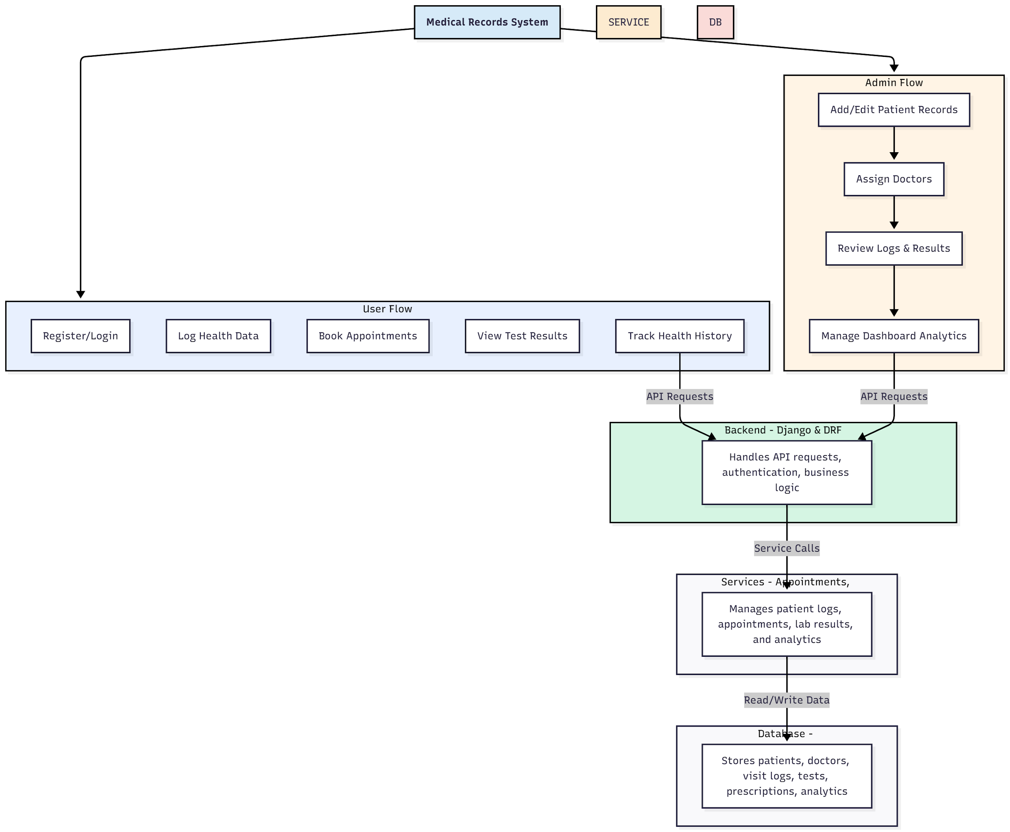

WORKING OF THE PROJECT:
Patients register or log in to the Medical Records System to log health data, book appointments, access test results, and track medical history. The backend handles authentication, API requests, and business logic, while services manage appointment scheduling, lab test tracking, and analytics dashboards. Administrators can add or edit patient records, assign doctors, review visit logs, manage prescriptions, and generate analytics for operational decision-making. This integrated system ensures secure, centralized, and efficient healthcare management for both users and administrators..

SOFTWARE REQUIREMENT:
- Backend:
  - Python 3.x
  - Django
  - Django REST Framework
  - SQLite/PostgreSQL
- Frontend:
  - Node.js and npm
  - React.js
  - Axios
- Development Tools:
  - Visual Studio Code
  - Postman (for testing APIs)
  - Git/GitHub (for version control)
- Server/Deployment (Optional):
  - Gunicorn, Nginx, or Heroku/AWS for hosting

ADVANTAGES OF THE PROJECT:

• Centralized patient record management
• Easy access to health history and test results
• Appointment scheduling with doctor assignments
• Analytics dashboard for hospital operations
• Secure authentication and data privacy
• Efficient tracking of prescriptions and lab results
• Reduces errors in manual record-keeping
• Enhances communication between patients and healthcare providers

APPLICATIONS OF THE PROJECT:
• Clinics and hospitals
• Personal health management
• Telemedicine and online consultations
• Diagnostic and lab test tracking
• Prescription and medication management
• Healthcare analytics and reporting
• Patient-doctor communication platforms
• Medical research and trend analysis

REFERENCES:

- Django REST Framework Documentation — Django Software Foundation. Django Documentation. Available: https://docs.djangoproject.com/
- Django REST Framework. DRF Documentation. Available: https://www.django-rest-framework.org/
- React. React Official Documentation. Available: https://reactjs.org/docs/getting-started.html
- Redux. Redux Documentation. Available: https://redux.js.org/introduction/getting-started
- PostgreSQL Global Development Group. PostgreSQL Documentation. Available: https://www.postgresql.org/docs/
- MySQL. MySQL Reference Manual. Available: https://dev.mysql.com/doc/
- Git. Git Documentation. Available: https://git-scm.com/doc
- Node.js. Node.js Documentation. Available: https://nodejs.org/en/docs/
- Axios. Axios Documentation. Available: https://axios-http.com/docs/intro
- Socket.io Documentation – https://socket.io/docs/

